Q6. Read the description of computer network access control that follows and then answer the sub-question.

Company X uses a network for communications in-house and with affiliated companies. The figure below shows the configuration of Company X’s LAN. The communications protocol is TCP/IP, and the numbers in the figure are the IP addresses. (The IP addresses shown are fictitious).
For security reasons, connections with affiliated companies are made through a gateway router. The gateway router has a function that checks the contents of all packets that pass through the router and discards all packets that do not meet the preset conditions. These conditions are registered beforehand in the Settings Table.

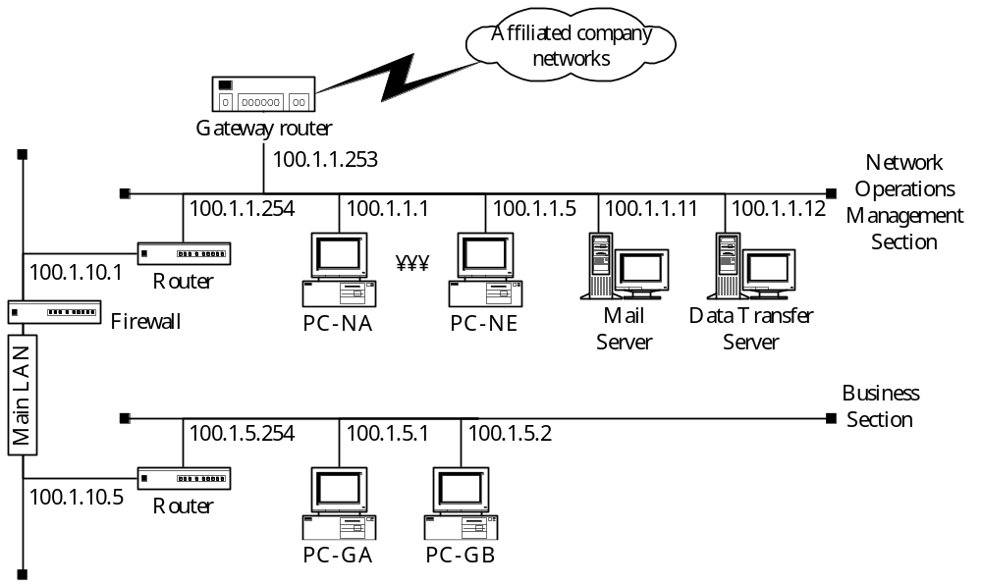
Fig. Company X's LAN Configuration

Table 1 shows an example of the Settings Table in the gateway router. The conditions are set as a combination of the IP address, which is the identification number in the IP layer, and the port number, which is the identification number in the TCP layer. In other words, if an IP address and a port number are specified in one line of the Settings Table, the gateway router will only allow packets corresponding to that IP address and port number to pass. When “0.0.0.0” is specified in the IP address field in the Settings Table, or “0” is specified in the port number field, it indicates that there is no restriction on the address or port number in that field. When a range of values is specified with “ : ”, it indicates that the router will allow packets corresponding to an IP address or port number within that range to pass. Packets attempting to pass through the gateway router are checked against each line of the Settings Table in order; packets which do not meet any of the conditions are discarded.

Table 1 Example Settings Table in a Gateway Router (for telnet)
 | IP layer |  | TCP layer
 | Sending IP address | Destination IP address | Sending port number | Destination port number
Condition 1 | 100.1.1.1 : 100.1.1.5 | 0.0.0.0 | 0 | 23
Condition 2 | 0.0.0.0 | 100.1.1.1 : 100.1.1.5 | 23 | 1026 : 65535

The example settings shown in Table 1 are designed to allow virtual terminal function (telnet) service packets to pass from within the company to outside the company, and to allow reply telnet service packets to pass from outside the company into the company. As a result, it is possible to access a telnet service (with the port number fixed to “23”) that is provided by servers outside of Company X from PC-NA through PC-NE (IP addresses 100.1.1.1 to 100.1.1.5) in the Network Operations Management Section. The settings also allow packets from outside the company to pass through only to port number 1026 and higher.

Sub-Question
The following request for connection to Company X’s LAN was received from Company Y, an affiliated company:

Company Y wishes to use the data transfer function service from two of its computers (with IP addresses 101.1.1.1 and 101.1.1.2) by connecting to the data transfer server (with IP address 100.1.1.12) in Company X's Network Operations Management Section.

What condition needs to be specified in the gateway router Settings Table in order to meet this request? Select the values that should be inserted into the corresponding boxes (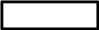) in the following Settings Table (table 2) from the choices provided below. Assume that Company X’s server can use port numbers 1024 and 1025 simultaneously for data transfers. Any of the choices may be selected more than once.

Table 2 Gateway Router Settings Table (for Data Transfer)
IP layer |  | TCP layer
Sending IP address | Destination IP address | Sending port number | Destination port number
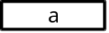 | 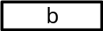 | 0 | 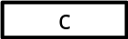
 |  | 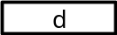 | 1026 : 65535

Answer group for a through d:
a) 0 b) 0.0.0.0 c) 100.1.1.12
d) 100.1.1.12 : 101.1.1.1 e) 100.1.1.12 : 101.1.1.2 f) 101.1.1.1
g) 101.1.1.1 : 101.1.1.2 h) 1024 i) 1024 : 1025
j) 1025

